PRACTICE 4
Determine the validity of the following three statements. Circle either True or False.
1. Group functions work across many rows to produce one result per group.
True/False
2. Group functions include nulls in calculations.
True/False
    - The WHERE clause restricts rows prior to inclusion in a group calculation.
True/False
The HR department needs the following reports:
4. Find the highest, lowest, sum, and average salary of all employees. Label the columns
Maximum, Minimum, Sum, and Average, respectively.
- Modify the query in lab_04 to display the minimum, maximum, sum, and average salary for each job type.
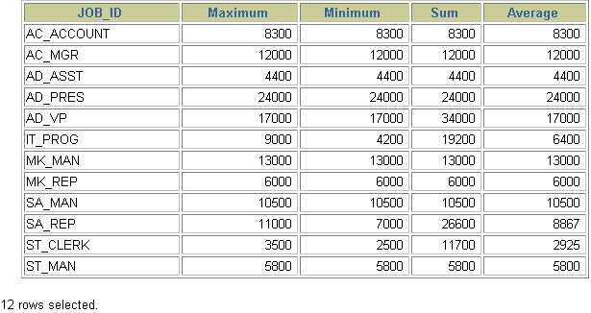
- Write a query to display the number of people with the same job.
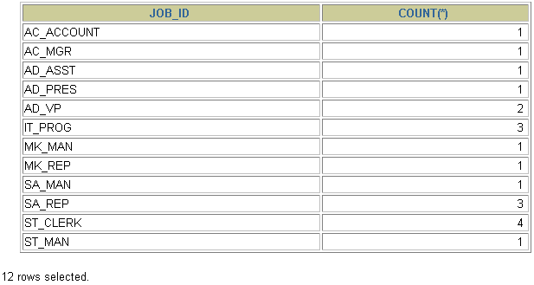
7. Determine the number of managers without listing them. Label the column Number of Managers.
8.Find the difference between the highest and lowest salaries. Label the column DIFFERENCE.

